

**Setup Instructions for PNR Integration with Sabre Red 360 and ClientBase Online v4.06**

# Step 1

Please review system requirements for [Sabre Red 360.](https://agencyeservices.sabre.com/Products/Sabre-Red-360.aspx?documentId=%7bBC1C3A32-3C93-EF0F-8CD5-39329179FA59%7d)

(scroll to middle of page, click on Support tab and then click on Technical Requirements)

# Step 2

In Sabre Red 360, verify you have the ClientBase Online Plug-in

*Go to* ***Help*** *and click on* ***About Sabre Red 360***

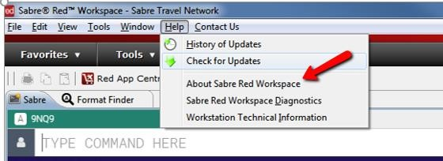

Click on **Configuration Details**

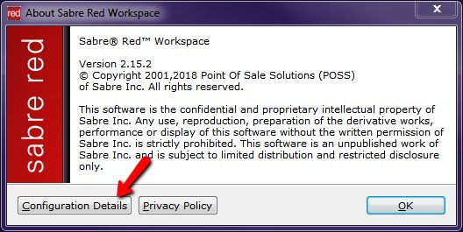

Under the **Plug-ins** tab, verify that **ClientBase Online** is listed



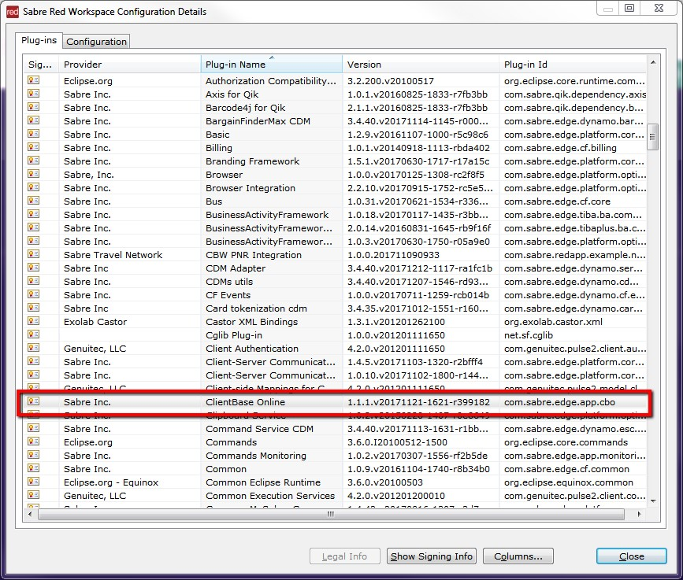

If the ClientBase Online plug-in is not found in your list, go to **Help** and click on **Check for Updates.** After updates, restart Sabre Red 360 and check again.

# Step 3

Installing Active X Controls for the Merge to PNR and PNR Import features is no longer necessary, however, you will need to access ClientBase Online from within Sabre Red 360 to use the ClientBase Merge to PNR and PNR Import features. All other ClientBase Online functionality remains available via Internet Explorer.

**To launch ClientBase Online from Sabre Red 360:**

*From the black toolbar, select* ***Tools > Customer Management > ClientBase Online****.*



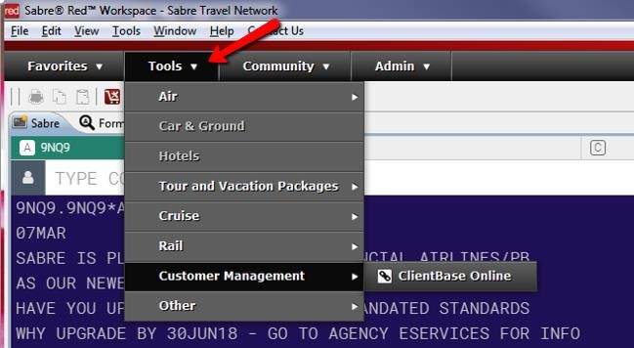

*Reminder: Sabre SSO (single sign on) is not available for ClientBase Online at this time. Be sure to use your assigned ClientBase Online PCC when logging in which may be different than the Sabre PCC you log in with.*

# Step 4

Follow the usual steps in ClientBase for Merge to PNR and PNR Import.

